HTML 5 – ASSIGNMENT

1. What are the new tags added in HTML5?

Ans. the following tags are added in the html 5

* <nav> - for navigation links.

Code:

<nav>

<ul>

<li><a href="#home">Home</a></li>

<li><a href="#about">About</a></li>

<li><a href="#contact">Contact</a></li>

</ul>

</nav>

* <progress> - for showing the completion progress of a task.

Code:

<progress value="70" max="100">70%</progress>

* <output> - for the result of a calculation.

Code:

<form oninput="result.value=parseInt(a.value)+parseInt(b.value)">

<input type="range" id="a" value="50"> +

<input type="number" id="b" value="50"> =

<output name="result" for="a b">100</output>

</form>

* <section> - for grouping related content together.

Code:

<section>

<h2>Section Title</h2>

<p>Grouped content goes here...</p>

</section>

* <time> - for representing dates and times.

Code:

<p>Published on: <time datetime="2023-01-01">January 1, 2023</time></p>

* <video> - for embedding video content.

Code:

<video width="320" height="240" controls>

<source src="example.mp4" type="video/mp4">

Your browser does not support the video tag.

</video>

* <main> - for the main content of the document.

Code:

<main>

<h1>Main Content</h1>

<p>Main content goes here...</p>

</main>

* <article> - for representing a self-contained piece of content that could be distributed and reused independently.

Code:

<article>

<h2>Article Title</h2>

<p>Article content goes here...</p>

</article>

* <abbr> - for abbreviations or acronyms, with optional explanation.

Code:

<p><abbr title="World Health Organization">WHO</abbr> is a global health organization.</p>

* <cite> - for referencing the title of a creative work.<meter> - for representing measurements.

Code:

<p><cite>The Great Gatsby</cite> by F. Scott Fitzgerald</p>

* <ruby> - for ruby annotations.

Code:

<ruby>

漢 <rt>Kan</rt>

字 <rt>ji</rt>

</ruby>

* <wbr> - for line break opportunities.

Code:

<p>This is a very long word a line break: abcdefghick<wbr>xyzxyzyxz </p>

2. How to embed audio and video in a webpage?

* <video>

The HTML <video> element is used to show a video in webpage.

Code:

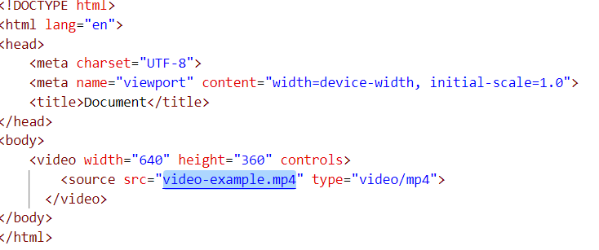

Output:



* <audio>

The HTML <audio> element is used to show an audio in webpage.

Code:

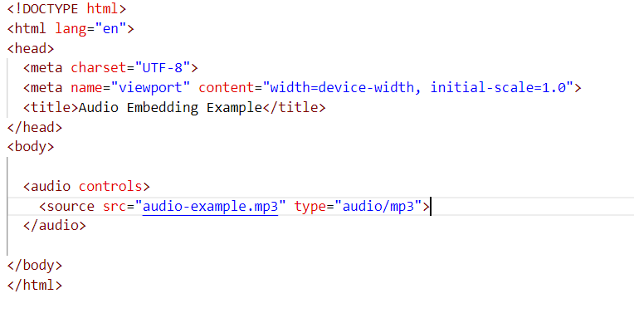

output:



3. Semantic element in HTML5?

Ans. A semantic element clearly describe its meaning.

Eg. Non-semantic elements:- <div>, <span>

Eg. Semantic elements:- <form>, <table>, <nav>

4. canvas and svg tags

* Canvas

Used drawing graphics,animations and other visual element on web page.  
  
code:

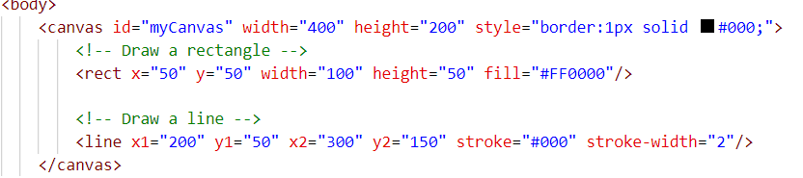

Output:



* Svg

The <svg> tag is also part of HTML5 and stands for Scalable Vector Graphics. It is an XML-based language for describing two-dimensional vector graphics.  
  
code:  
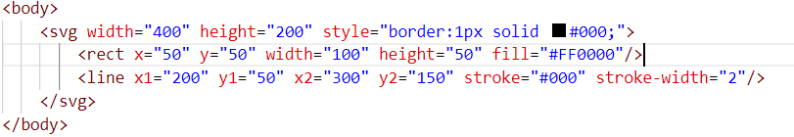

Output:

